Requirements Gathering:
- Stakeholder Analysis:
- Customers (Users):
People who use the website to browse and buy clothing. They need an easy and fast shopping experience.
- Admin:
The person who manages the system. They need to add, edit, and delete products, and manage orders.
- Business Owner:
The owner of the store who wants to increase sales and manage the business easily.
- Development Team:
The team responsible for building and maintaining the system using Angular and ASP.NET.

- User Stories & Use Cases:
- Use Case Diagram:
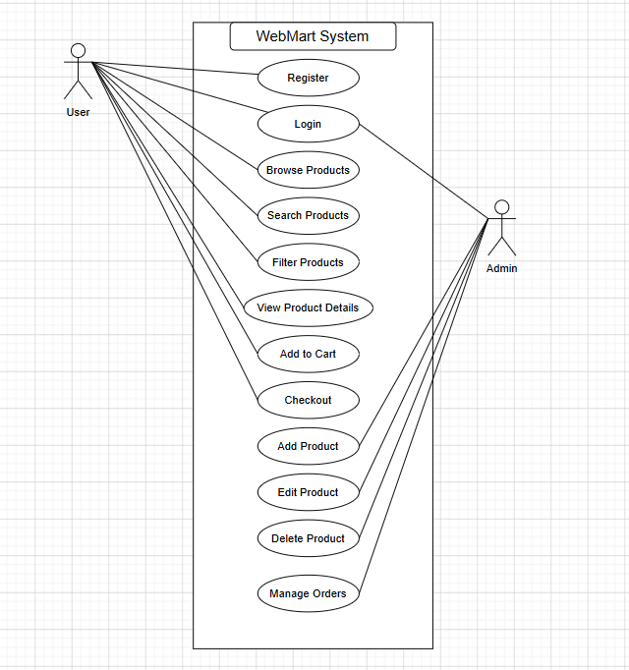
- User Story (buy Product):
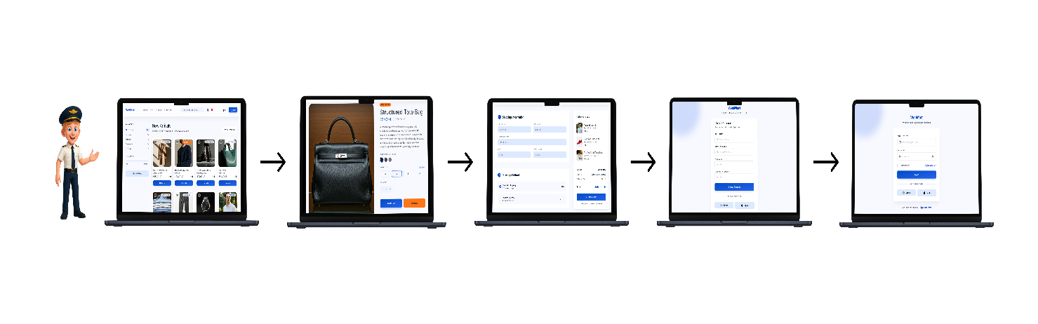
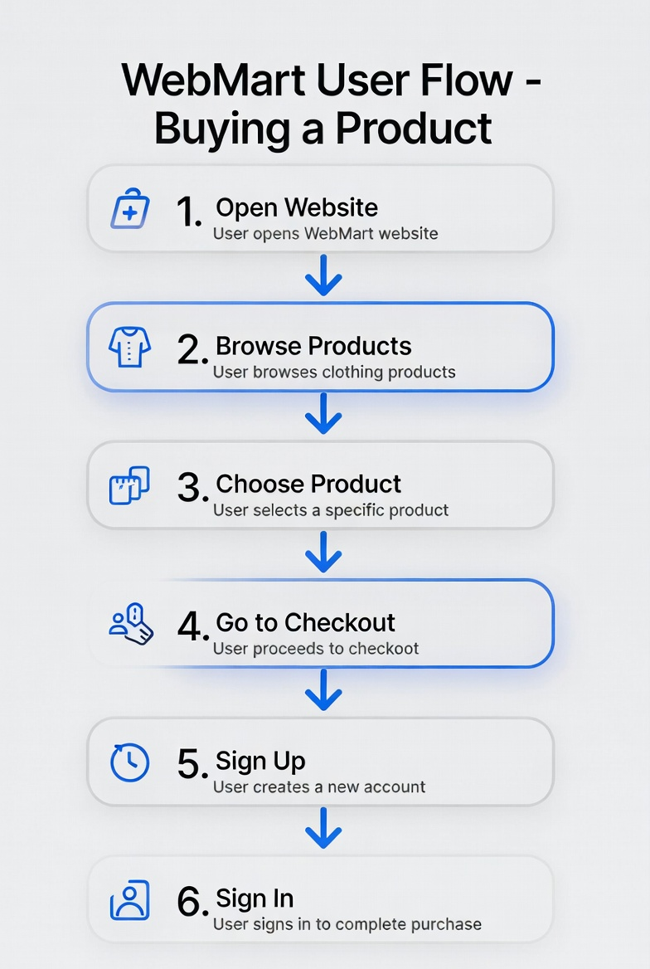

Functional Requirements
- The system allows users to register and login.
- The system allows users to browse products.
- The system allows users to search for products.
- The system allows users to filter products by category and price.
- The system allows users to view product details.
- The system allows users to add products to the cart.
- The system allows users to complete checkout.
- The system allows admin to manage products.
- The system allows admin to manage orders.

Non-Functional Requirements:
- Performance:
The website should load pages quickly (within 2–3 seconds).
- Usability:
The system should be easy to use with a simple and clear interface.
- Security:
User data such as passwords should be protected.
- Reliability:
The system should work without errors and be available most of the time.
- Responsiveness:
The website should work on mobile, tablet, and desktop devices.

